This project had us utilize OPENCV in python to create a template matching algorithm in python so we could use it to find Waldo. There are any defined template matching algorithms, each having their own properties to take different pixels into consideration to generate a score. This score is then analyzed to find the approximate location of the template image in the sample image. The four methods I tested were CCOEFF, CCOEFF_NORMED, CCORR, CCORR_NORMED. Each will be described later in the report, and their mathematical equations will be given. We used the results given to create a math plot, so we could visually see the results in a high/low value form, and using this the algorithm is able to highlight the result which should be Waldo’s face in the resulting image. Of those I tested, CCOEFF works much better than CCORR at locating Waldo. I feel this may be because CCORR uses multiplication values of the template and sample image, and sums them up. This will favor values that do share similar colors, but because Waldo’s face is primarily light colored, it can be easily fooled by large areas of light colors. CCOEFF is able to discern his face, because though it does take into consideration the multiplication, it looks at the reciprocal of size which does help.

In either method, once the result is normalized (so that extreme values are moved towards the standard deviation of the dataset), Waldo is able to be located. Each one squares both values of the numerator and takes the square root. Both normalized functions are able to find him, but would possibly have more issues finding him in an image with objects that do look similar to Waldo, that are not him because it does dilute the correct responses of the template on the correct area of the sample.

Here are my results and thoughts for each of the four results:

Method 1: TM_CCOEFF

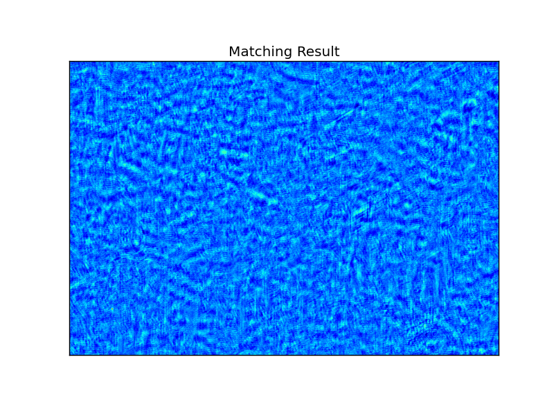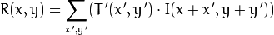

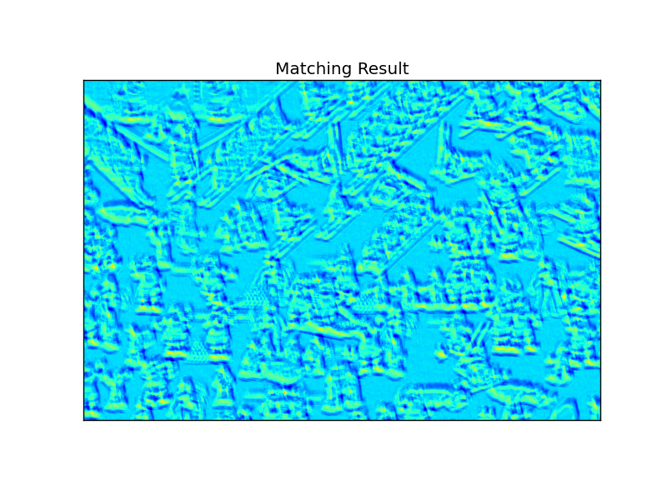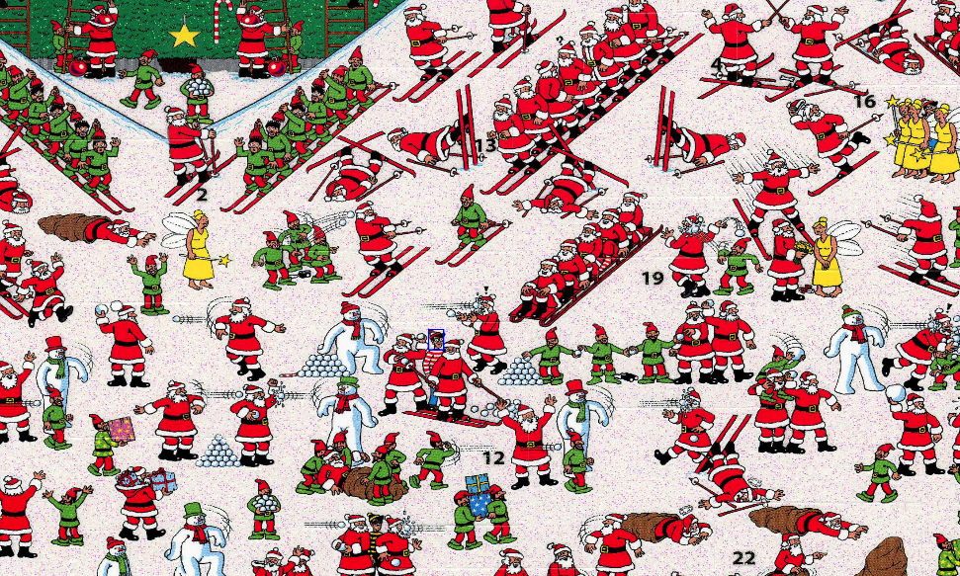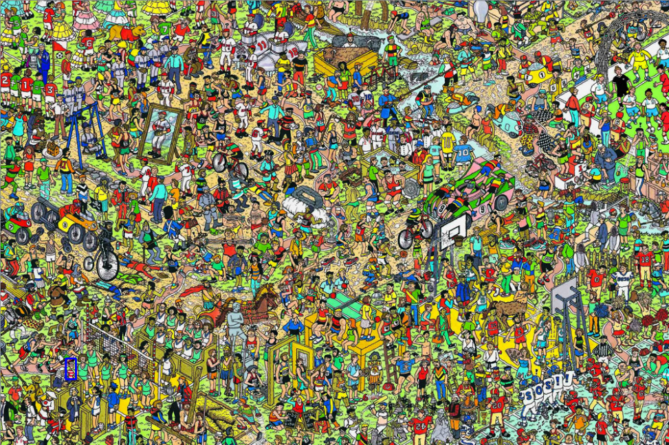

The COEFF algorithm utilizes multiplication of pixels from the template image and the corresponding pixels from the target image. This then adds the reciprocal of the size of the template image. This algorithm is accurate enough to locate Waldo in both images. It does account for the size of the image, which is different from CCORR.

Method 2: TM_COEFF_NORMED

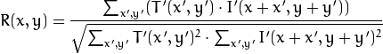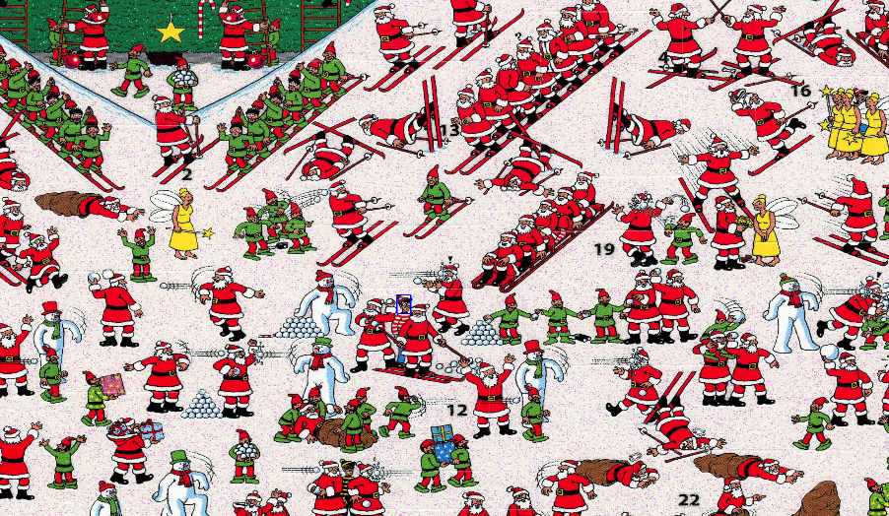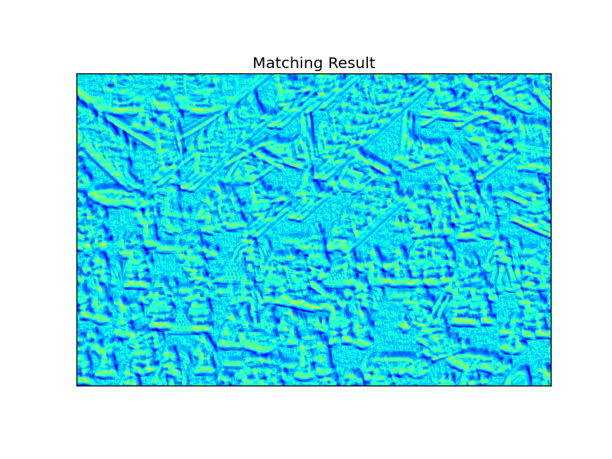

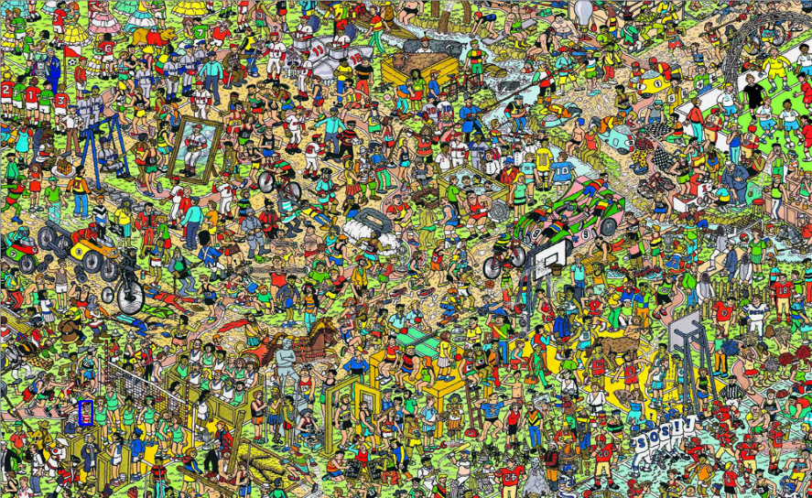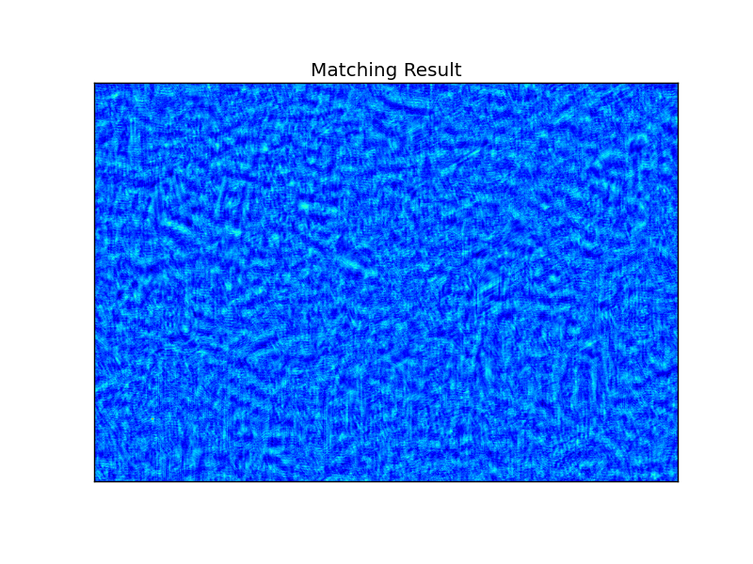

The CCOEFF NORMED function is very similar to the normal CCOEFF function, utilizing the same math for the numerator of the answer. However, we then divide the result by the standard deviation. This normalizes the result and does result in more “normal” results. This means that more extraneous values are brought more to the average to remove peaks and valleys in the results. This operation was also able to find Waldo in both images.

Method 3: CCORR

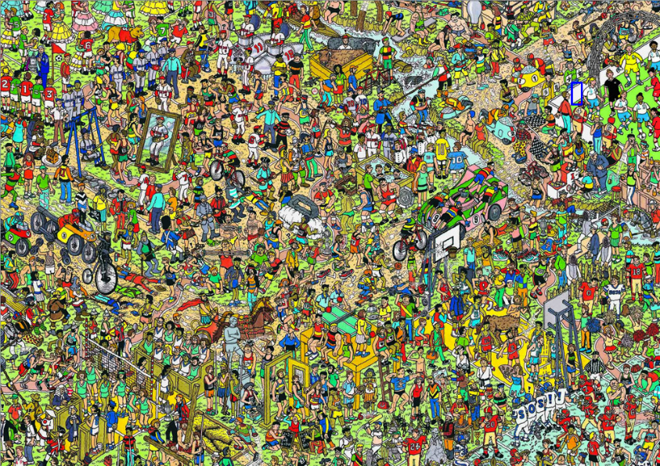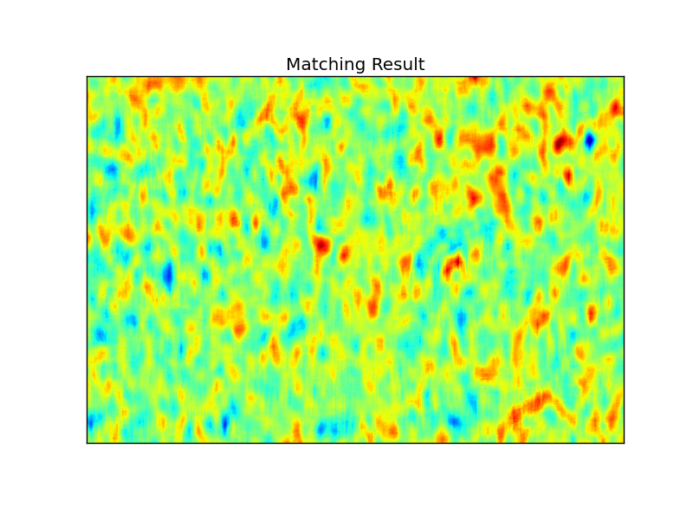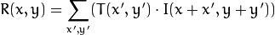

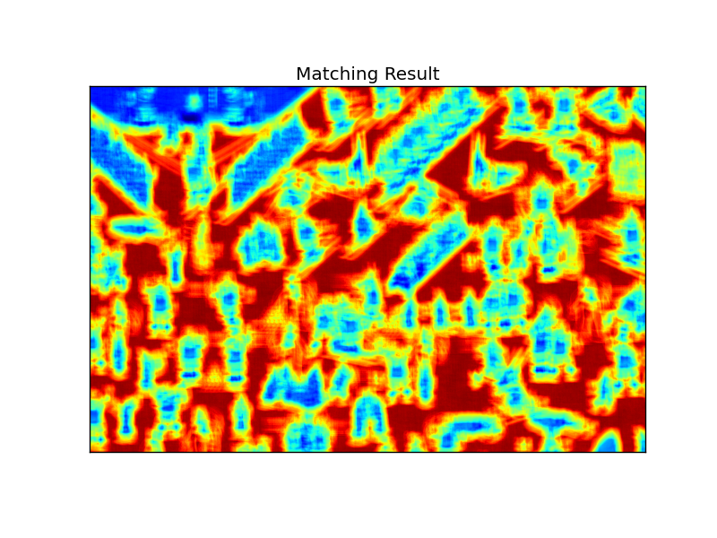

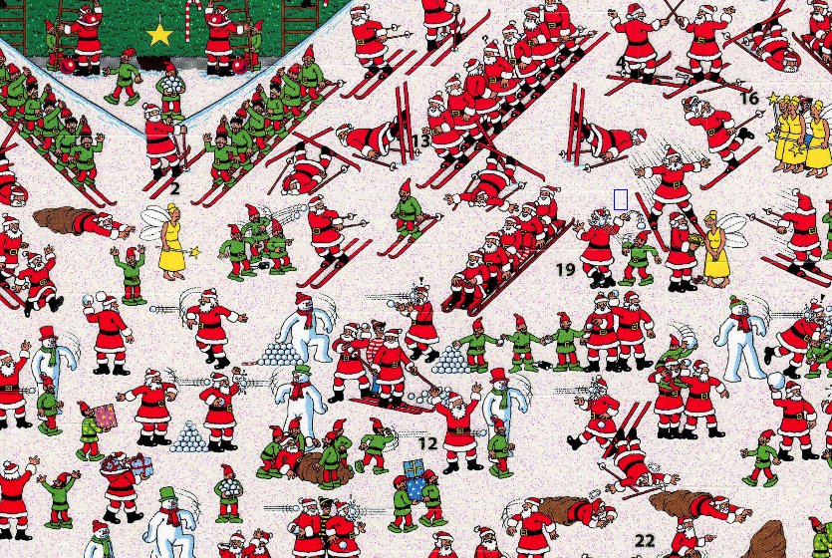

CCORR is an algorithm that uses cross-correlation. The algorithm lays the sample on the target image, and for each pixel position, multiplies the template image pixel value by the target pixel image value. We then sum the scores for a score. This algorithm was not able to locate Waldo, and seems to favor light picture areas for its pick of location.

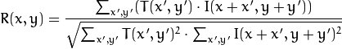Method 4: CCORR_NORMED

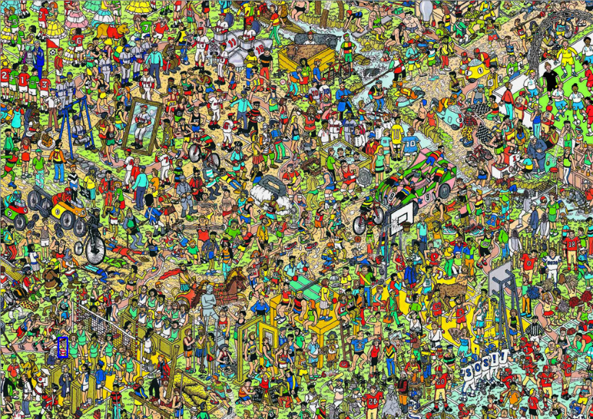

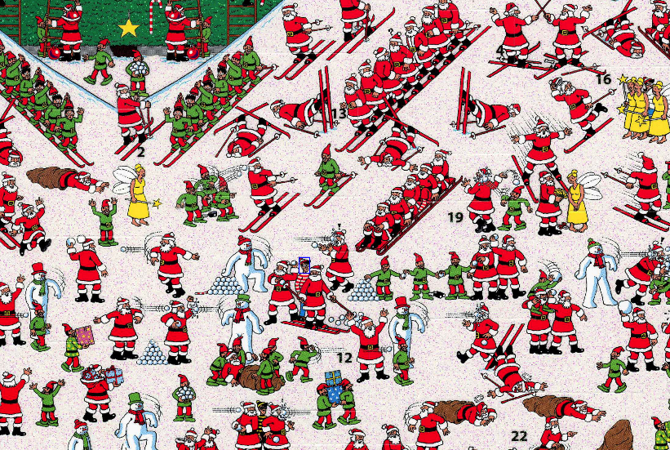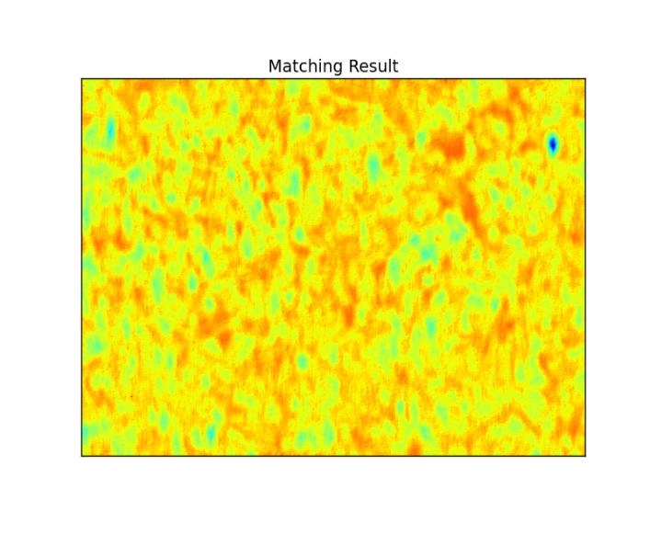

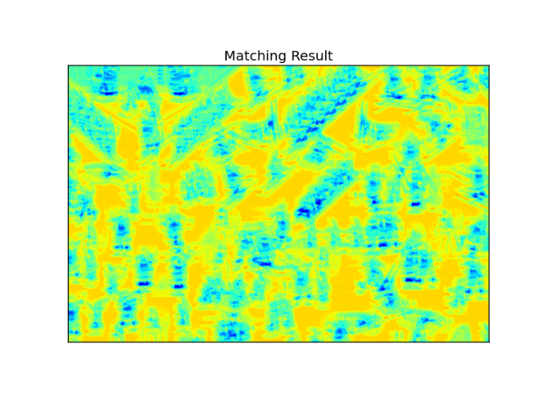

Similar to the CCORR algorithm, we first multiply the template image pixel value by the target image value pixel, and sum the scores. However, this algorithm takes an extra step, and divides by the standard deviation of the result, which allows extreme data values to be removed from the sample. As mentioned in the CCOEFF_NORMED algorithm section, this removes the peak and values from the results, thus smoothing out or results, though the high values where Waldo is located should still be present. This resulted in Waldo being found for both image sets.